So I think it would be easiest if I put your words in blue, my corrections in yellow, and my comments about why I made these corrections in red. Red highlight is my commentary, yellow highlight is what I would change, and blue highlight is the original text.

Visit Houston   
Houston Visit

To my surprise I am in love with this city.  
I`ve been to Houston a few times, but in the past it has only been for work, and I was not able to explore the city

In my last visit in July I took the opportunity that my husband had to work there and I finally came to explore the city with my baby girl.

However, in my last visit in July, it was my husband who had to work, so I was finally able to take the opportunity to explore the city with my baby girl.

I like “however” as a transition here, because this sentence is very connected to the previous one. Also, I moved around the word order, so that it matches the sentence before it better.  
We had stayed in Houston for 7 days, which we mostly spent at the hotel because it is just impossible to be outside during the Texas summer heat.  
  
We stayed in two different hotels while we visited because me and my hubby are hotel freaks and we love exploring different hotels.

That was okay though, because my hubby and I are hotel freaks and we love exploring different hotels. We stayed in two different hotels while we visited.

Here, I like having a transition from the previous sentence, since a lot of people would think that “that's a bummer that you had to stay inside.” “That was okay though” relieves that expectation, and it's seen as a plus.

THE First hotel that we stayed at was in galleria area. It`s the perfect area for anyone who loves to shop.   
You can find almost any store that you are looking for and enjoy a great dining experience all in the same area.

This was my first time visiting the galleria mall. I was fascinated by not only the size of the mall but also by the fact that there was a hotel located inside the mall that had rooms with a view of the mall from the balcony. We did not get to stay there but it was really cool to see.

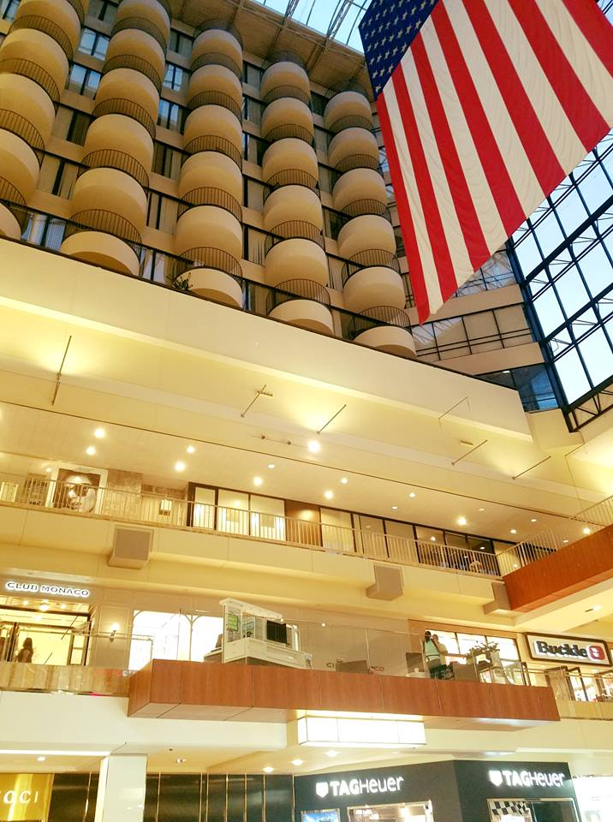  
  
Our second hotel was in Downtown Houston. I was not excited to stay there just because of the chaos that usually goes on in downtown areas but somehow my husband convinced me .

We were lucky enough to have a beautiful room with a view facing downtown Houston at the Le Meridien. It was a very nice and cozy hotel. I liked it because it`s a vintage hotel that just recently went through a fancy remodeling which made it very nice to visit. The only bummer was that this hotel didn`t have a pool but it wasn`t too bad because there was a very cool rooftop bar with an amazing view.  
  
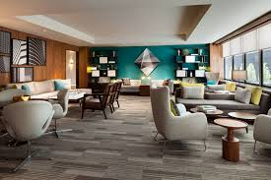

I have been to many downtown areas before and I was impressed by downtown Houston.

It was very unique, clean, and interesting. It had it`s shady areas like every downtown does, but it was not scary at all to walk around and enjoy the city. There was also a good amount of construction being done to make the city even more attractive.

My favorite part of the town was graffiti walls. I am obsessed with graffiti walls.

There were so many and I was not been able to make it to most of them because I was with my new born baby and it was extremely hot, but we made it to one that was close to our hotel.

It was a huge block with 6 beautiful graffiti paintings. My two favorite were "dream big" & "made in Texas" , and I absolutely had to take a photo there of with my baby girl.  
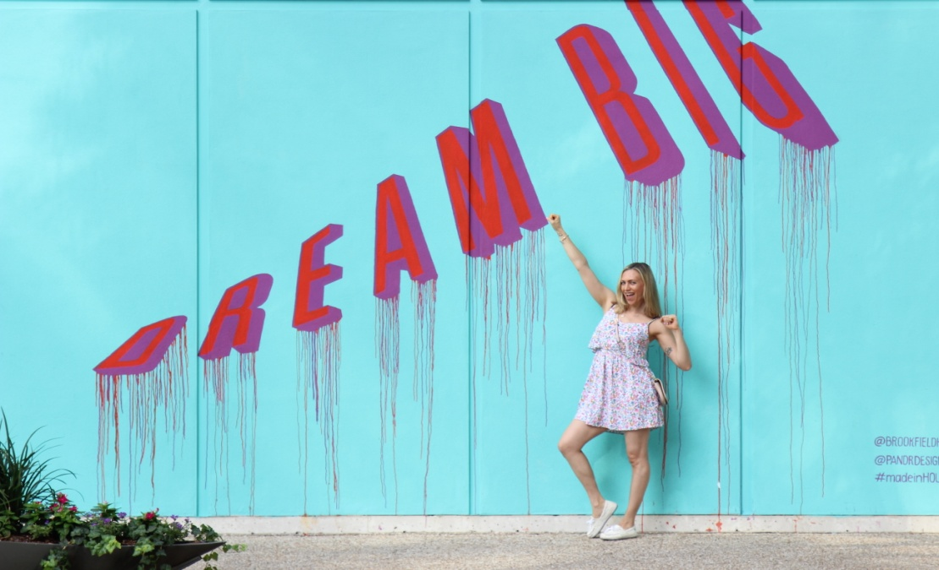  
You can find it right on (location)

I'm a little confused here because you mention taking a photo with your baby girl, but then your baby girl is not in the photo. I would either change the photo to one with your baby, or just remove “with my baby girl” from the text.  
  
My second favorite part was a huge park named "Discovery Green Park". This park was so beautiful, green, colorful, and it even had WiFi. There was an open air reading space, you could borrow games and balls to play with your family, and you could even rent a kayak and take a ride. There was a lot of green grass where you can chill out. The park offered complimentary live concerts, movie nights, and free yoga. Moreover, there is was a fun fountain where kids can go wild a cool down splashing in the water.

(photo)  
  
If you a blogger or just someone who loves taking cool photos you do not want to miss the "Sugar and cloth walls". That was such a fun experience (at least it was for me). You can get so wild and creative with this wall and take fun family, or professional, or engagement, or whatever kind of photos you want.  
There was even a changing room there on the side. To top it all off there was also a set of fun rainbow stairs where you could take even more fun photos.

You can get so wild and creative with this wall and take fun family photos, professional photos, engagement photos, or whatever other kinds of photos you want.

I know this was a sentence we went over at the coffee shop, but as I read it again, I like saying it this way a lot better, because when you first get to the list of items, it's not clear that you are talking about photos, but this way you can get the list to agree, and the reader knows that you are talking about photos the entire time.  
  
(photos)   
It is located at green street downtown 1201 main street just around the corner of Forever XXI

Of course you can find plenty variety of different of restaurants, bars, etc..  
There is even an aquarium restaurant located at the downtown aquarium. We did not were not able to make it there but if you want to explore this place make sure to make a reservation because it`s always packed. (photos)

I prefer “were not able to” here, because I think what you are trying to say is, “we wanted to make it there, but we were not able to”, but “did not” sounds sort of like you deliberately did not go there.

If you are ready to awake the inner child within you awaken your inner child and have some fun on downtown rooftops and at the same time create magical life time memories make sure to reach out to Philipe.

If you are ready to awaken your inner child, have some fun on downtown rooftops, and create magical life memories, make sure to reach out to Philipe.

I like this sentence as a separated list. One “and” is okay, but when you have more than two clauses, the rhythm of the sentence sounds a lot better with commas rather then repeated “and”s. Also, I removed “at the same time” because the way the sentence is structured, the reader can tell that these things are happening “at the same time” already. “awaken” is the active form of awake (to be awake means that you are not asleep, whereas “to awaken” means to bring something from being asleep to being awake), and “inner” and “within” mean similar things in this context, so it makes sense to only use one of them. I love the imagery, this slight modification just makes it pop a little more.

Philipe, he is a very talented teen photographer that has been on every possible downtown rooftop and his work is speechless leaves me speechless.

Here, since you mention Philipe, putting “he” again, while grammatically okay, is redundant and a little strange. Also speechless is not a word you would use to define Philipe's work (you could use a word like “phenomenal” for that) but instead “speechless” is a word you use to describe how you feel when you see Philipe's work, which is why I made that change.

I found him on Instagram and we had so much fun shooting yoga photos together. The adrenalin adrenaline rush from this experience was so high beyond my wild wildest expectations. I literally cannot wait comeback to come back to Houston and do it again.

Just some minor edits here. When adrenaline is used in this way, it is usually used as an adjective, so “adrenaline rush” sounds a little better to me. “Wild expectations” sounds more like “I am a wild person with wild expectations” where as what you want to say here is that it was beyond what you expected, so “wildest expectations” works better. And since you have “beyond my wildest expectations” I would remove “so high” because both the statements say the same thing.  
  
(photos)

There are many other interesting things in Houston, that are on my list of things to see on my next visit in a few months.

- Hines water wall park Hines Waterwall Park is another a beautiful and unique place where you can enjoy nature and take fabulous photos. This water wall re-circulates 11000 gallons of water per minute! I cannot wait to see this whit with my own eyes.

Just some technical corrections here. Since this is the first thing you mention in the list, it is not “another” place. Another is used when you have already mentioned something.

- Houston has a rich verity variety of museums such as the Museum of Natural Science, The Health Museum, and The Children`s Museum, and much more.

You only need “and” on the last item of a comma separated list.

- There are also things like the city bike tour, where you can rent a bike for just a few bucks in certain part of the city, take a ride for as long as you wish to and return it at any station around the city.

There are also things like the city bike tour. You can rent a bike for just a few bucks in any part of the city, take a ride for as long as you wish, and return it to any station around the city.

This sentence should be restructured a bit. I like splitting it into two sentences, it just feels more natural to me. I changed “certain” to “any”, since certain makes it seem like you must be at a “certain” location to rent a bike, but I think what you are trying to emphasize is the freedom in renting anywhere and dropping off anywhere, so “any” works better. Also, “wish to” is another of those things that is grammatically fine, but sounds a little strange.

- Kemah boardwalk is an old fashioned water front amusement park is about 20 miles away from downtown and you anyone can have so much fun there.

Last but not least, there is Kemah boardwalk. Kemah is an old fashioned water front amusement park about twenty miles away from downtown. It’s so much fun for everyone there!  
I like adding some transition to this last list point, I'm not sure why but it feels better to me. “Lastly” would also work. I split this up into a few sentences. Since this is a list, I think it's best to keep the sentences in the list short. It also matches the other items in the list better this way.

If you are planning to visit few multiple attractions then you would probably would enjoy saving some money by getting a city pass.

If you are planning to visit multiple attractions then you might want to look into getting a city pass to save some money.

Any time you have an “if” you have to have a “then” later in the sentence. Also, “few” sounds like “not very many” and “multiple” works better here. “a few” would also work, but I like “multiple” better. I also restructured the ending of the sentence a little, it just sounds better to say it this way.

With a city pass you can choose 5 five attractions included including museums, the Houston zoo, aquarium, Kemah boardwalk, etc. for a very cheap price.

For short numbers, it's generally “more proper” to write out the number. That's a very minor thing. The rest are just minor things.  
  
(photos)

This city is a great destination if you are looking for a relaxing style escape or just a little change of pace . If you are planning to visit Texas in general and you want to relax during the day, chill out by the pool, catch up on some sleep, enjoy a good hotel and a book, explore new museums, and take fun walks or rides early in the morning and late in the evening, then Houston is the city for you. You don`t want to miss this city!  
I would get rid of “in general” because it feels unnecessary to me in the sentence. Everything else is good, this is a very nice closing paragraph. I added an exclamation point at the end, because that last sentence is very much an exclamation.